Janice Ainembabazi

Southern New Hampshire University

CS-255 System Analysis and Design

Prof. Maureen Kinkela

October 5th 2024

# CS 255 Business Requirements Document Template Resubmission

Complete this template by replacing the bracketed text with the relevant information.

This template lays out all the different sections that you need to complete for Project One. Each section has guiding questions to prompt your thinking. These questions are meant to guide your initial responses to each area. You are encouraged to go beyond these questions using what you have learned in your readings. You will need to continually reference the interview transcript as you work to make sure that you are addressing your client’s needs. There is no required length for the final document. Instead, the goal is to complete each section based on your client’s needs.

**Tip:** You should respond in a bulleted list for each section. This will make your thoughts easier to reference when you move into the design phase for Project Two. One starter bullet has been provided for you in each section, but you will need to add more.

## System Components and Design

### Purpose

*What is the purpose of this project? Who is the client and what do they want their system to be able to do?*

* For our client, DriverPass, this project’s purpose is to design and implement a system that offers driver testing and training services.
* According to the owner, Liam, and IT officer, Ian, they want the system to include features that will allow our client to manage and reserve appointments, track driver assignments, generate reports, and maintain records of training sessions.
* On the other hand, it will enable DriverPass clients to plan on-the-road training, take practice exams, and complete classes online as well ensuring online accessibility, security, and the ability for Liam to have full access and other user roles to have varying access authorizations.

### System Background

*What does DriverPass want the system to do? What is the problem they want to fix? What are the different components needed for this system?*

* The system should enable DriverPass customers to schedule driving lessons by making reservations, take tests available online, and monitor their progress in lessons. Additionally, it must to enable employees to create activity reports, organize and manage appointments, and monitor driver availability.
* There are flaws in the manual method currently used to schedule and manage driving lessons. DriverPass aims to improve client interactions, offer online training, and automate these procedures.
* Based on the needs stated by Mr. Liam and Mr. Ian, the system will require components such as:
* A reservation and scheduling system
* An online learning platform for lessons and tests
* A user management system with different access roles
* A web-based interface for both customers and employees
* Functions for keeping track of and reporting customer actions
* Updates that are compatible and compliant with DMV rules and updates.

### Objectives and Goals

*What should this system be able to do when it is completed? What measurable tasks need to be included in the system design to achieve this?*

* After it's finished, users should be able to schedule classes, track and monitor their progress, do tests, and get materials for training. The staff members must to be able to manage reservations, assign drivers, monitor system activities, and generate reports.
* The system design should include:
* User interfaces for scheduling, lesson tracking, and test-taking
* Role-based access control for different users
* Data tracking and reporting functionalities
* Integration with DMV for regulatory updates
* A secure, cloud-based infrastructure to handle data storage and user interactions

## Requirements

### Nonfunctional Requirements

*In this section, you will detail the different nonfunctional requirements for the DriverPass system. You will need to think about the different things that the system needs to function properly.*

#### Performance Requirements

*What environments (web-based, application, etc.) does this system need to run in? How fast should the system run? How often should the system be updated?*

* Quick loading pages for fast test scores and easy navigation
* Be accessible on the web from anywhere with a good internet connection on different operating systems
* Handle many user logins and profiles without crashing or lagging
* Regularly updated to comply with any changes in the DMV rules and regulations

#### Platform Constraints

*What platforms (Windows, Unix, etc.) should the system run on? Does the back end require any tools, such as a database, to support this application?*

* DriverPass’ web-based application should run on all operating systems: Windows, Linux, MacOS, IOS, Android.
* The backend shall use a secure database system like MySQL
* Cloud services such as Azure and AWS shall be used to handle data storage in a cloud-based environment

#### Accuracy and Precision

*How will you distinguish between different users?* *Is the input case-sensitive? When should the system inform the admin of a problem?*

* Each user will have different login credentials, using verified emails and strong password distinguishing between the administration login and customer login authorization.
* Each user account will have a unique username and case sensitive password that has input and time sensitive limits
* In case of input errors, the DriverPass system will send alerts to the administration to correct and reset for user acounts.

#### Adaptability

*Can you make changes to the user (add/remove/modify) without changing code? How will the system adapt to platform updates? What type of access does the IT admin need?*

* Yes, without code changes, administration should be able to add, remove and (or) modify changes to user accounts through the administration interface without changing user input information
* Platform updates like the database, interface features, DriverPass terms and conditions, and DMV rules and regulations should be done without affecting the functionality of the system as users continue to use it.
* Administration users such as the IT Officer, Ian, and DriverPass owner, Liam, will have full access to accounts to be able to delete old employee accounts and create new employee accounts.

#### Security

*What is required for the user to log in? How can you secure the connection or the data exchange between the client and the server? What should happen to the account if there is a “brute force” hacking attempt? What happens if the user forgets their password?*

* User information which includes their name, email, date of birth, and a two factor authentication option will be required for the user to login.
* To ensure secure and encrypted client/server communication, the connection protocols will be made through HTTPS to protect user information by preventing data leaks.
* Multiple failed user login attempts will lead to access restriction which will require users to reset their passwords through secure processes like two factor authentication which will in turn prevent brute force hacking attacks.
* Users will be required to routinely change and reset their passwords through login and email verification so incase a user forgets their password they have an expiring verification link or code sent to their phone personal registered phone to recover the account.

### Functional Requirements

*Using the information from the scenario, think about the different functions the system needs to provide. Each of your bullets should start with “The system shall . . .” For example, one functional requirement might be, “The system shall validate user credentials when logging in.”*

* The system shall facilitate DriverPass online classes and practice tests to allow customers schedule and register for available packages, time, drivers and vehicles, view results, and progress statuses.
* The system shall be web-based and accessible anywhere online to allow user activity tracking.
* The system shall allow specific administrator roles such as the owner and IT officer to make and mange user accounts to give specific employees a level of permission or take it away.
* The system shall manage customer reservations and allocate to them available drivers and vehicles.
* The system shall allow customers to reschedule or cancel reservations keep the log and change activity for administration to see.
* The system shall validate user credentials when logging in, send automatic notifications for payments, reservations, cancellations, and DMV compliancy updates to all users.
* The system shall store user credentials upon registration such as: First Name, Last Name, Address, Contact Info and store account and progress report information such as: online test progress, driver notes, driver photo and student photo.
* The system shall allow password resets and two factor authentication when logging in.
* The system shall provide pickup and drop off locations based on given addresses when scheduling driving lessons
* The system shall allow for customer feedback, support and inquires through surveys, online forms and reviews.
* The system shall ensure safe payment transactions to be made and protect customers payment information.

### User Interface

*What are the needs of the interface? Who are the different users for this interface? What will each user need to be able to do through the interface? How will the user interact with the interface (mobile, browser, etc.)?*

On the system interface, the users will interact with the system via web browsers on any device ensuring smooth functionality across all platforms and adjust to different screen sizes for optimal usability. Each user type will have access to specific pages which include the Login Page, registration page, Contact information page, Driving course material page, reservations page, and so on, and tools suited to their role, making it easy to perform their tasks efficiently in such a way that:

1. Customers:

* Customers will access training materials, book and manage driving lessons, and track their learning progress through different devices such as mobile, tablets, iPads, on the web.

1. DriverPass Owner:

* Will have full control over system management, including user roles, passwords, reservations, and tracking customer progress.

1. IT Officer:

* The IT officer will manage system security, user roles, and technical operations to ensure smooth performance.

1. Admin:

* This includes other employees who will play different roles and have specific permissions granted by Driver Pass owner such the secretary who will manage customer reservations and handle day-to-day scheduling tasks.

### Assumptions

*What things were not specifically addressed in your design above? What assumptions are you making in your design about the users or the technology they have?*

* The design assumes that users will always be connected to the internet to access the system, know how to use and navigate the system, and accessing the system offline is not to be expected.
* It is assumed that besides customer information being received over the phone, the rest of the information and activity will be accessed through the application such that reservations, checking progress reports, will be preferred to be done through the application.
* It is assumed that the whole system build and process will be completed within the set timeframe with no allowance for delays, internet disturbances, natural disasters and so on.
* It is assumed that the budget will be enough to cover all expenses needed to create the application over the expanse of devices and operating systems without incurring extra costs.

### Limitations

*Any system you build will naturally have limitations. What limitations do you see in your system design? What limitations do you have as far as resources, time, budget, or technology?*

* The need for a constant connection to the internet to use the application which limits the functionality if some things could be accessed offline.
* The dependency on Third parties such as Maps for location, DMV databases to integrate regulations and policies which may delay to reflect correctly on the system in time.
* There is no mention of a maintenance and security plan to keep customer data safe and secure and update security measures to protect the system from evolving threats.

### Gantt Chart

*Please include a screenshot of the GANTT chart that you created with Lucidchart. Be sure to check that it meets the plan described by the characters in the interview.*

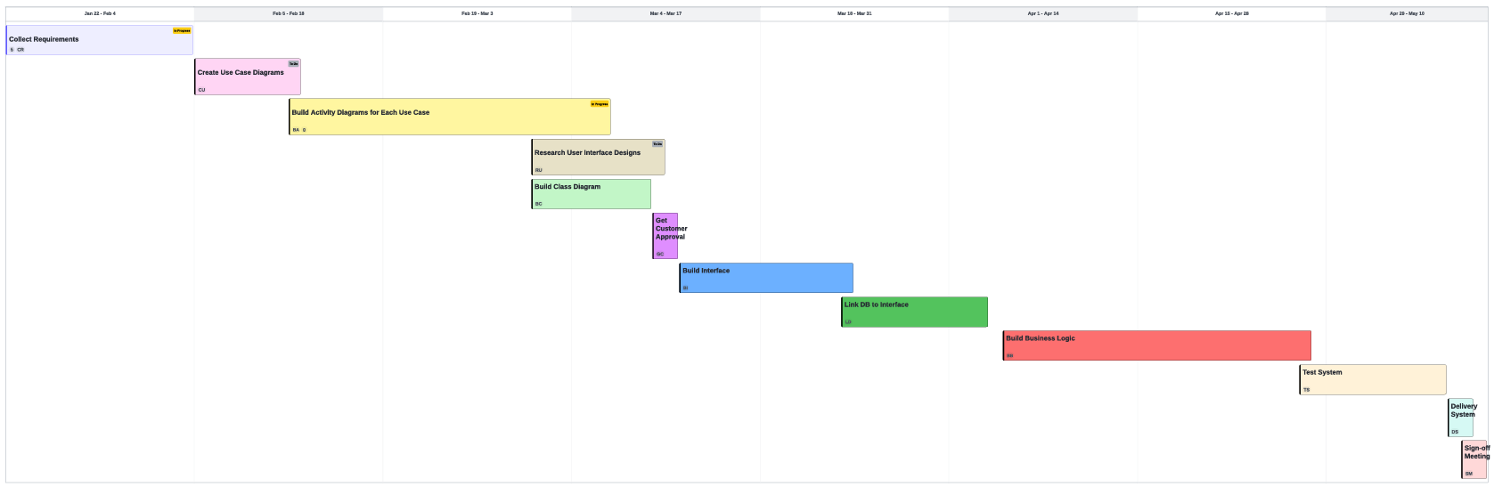

REFERENCE

Kinkela, M. (n.d.). Assignment Guidelines and Rubric. <https://learn.snhu.edu/d2l/le/content/1698519/viewContent/35468596/View>

Kinkela, M. (n.d.-a). CS 255 DriverPass Interview Transcript . Southern New Hampshire University.